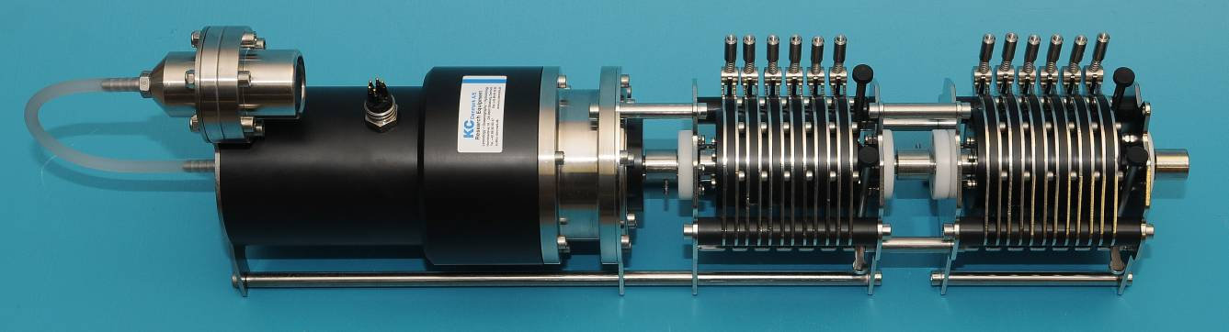
Peristaltic pump
6, 12 or 18 channels

Model 11.350/11.360

KC Denmark A/S
Research Equipment
Limnology  Oceanography  Hydrobiology
Quotation
Peristaltic pump, 6, 12 or 18 channels
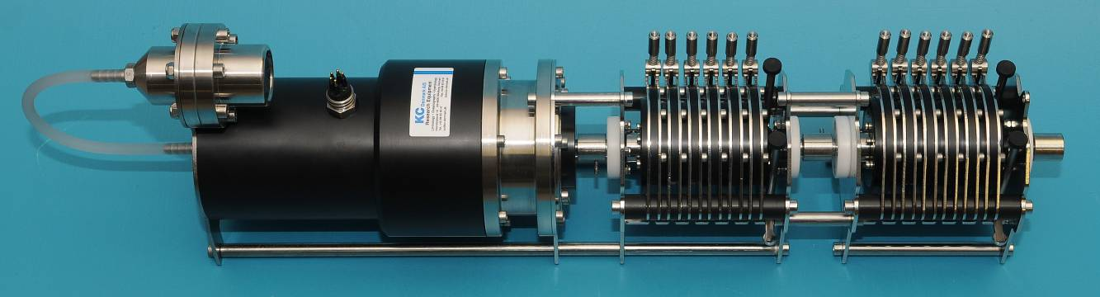
11.360 peristaltic motor with 12 channels. Easy configuration for more or less channels. Standard delivery comes without battery cylinder, time lapsed trigger, charger, plug and
cables.

Order no. | Qty. | Product |  | Prices - Euro
11.350 | 1 | Peristaltic pump  - 6 channels,  - Power supply: Max. 24 Volt DC, recommended: 10-24 Volt DC  - Pressure compensated: For 6000 m depth  - Motor: Detachable  - AISI 316 stainless steel  - Dim.: 570 x 130 x 200 mm  - Weight: 10 kg |  | 9.286,00
11.360 | 1 | Peristaltic pump  - 12 channels,  - Power supply: Max. 24 Volt DC, recommended: 10-24 Volt DC  - Pressure compensated for 6000 m depth  - Motor: Detachable  - AISI 316 stainless steel  - Dim.: 720 x 130 x 200 mm  - Weight 13,2 kg | 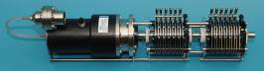 | 11.199,00
11.370 | 1 | Peristaltic pump  - 18 channels,  - Power supply: Max. 24 Volt DC, recommended: 10-24 Volt DC  - Pressure compensated for 6000 m depth  - Motor: Detachable  - AISI 316 stainless steel  - Dim.: 920 x 130 x 200 mm  - Weight 16,5 kg | 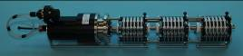 | 13.111,00
Spare parts and accessories
11.375 | 1 | Motor unit for peristaltic pump  - 0 channels  - Power supply: Max. 24 Volt DC, recommended 10-24 Volt DC  - Pressure compensated for 6000 m depth  - Extendable to 6, 12 or 18 channels by adding one or more modules 11.380  - Dim.: 400 x 130 x 200 mm  - Weight: 7 kg | 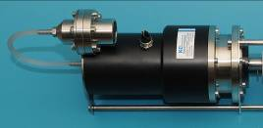
11.380 | 1 | Extension module  - 6 channels  - Weight 3,3 kg | 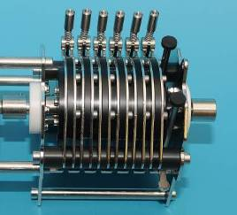 | 1.971,00
11.385 | 1 | Bottom frame for peristaltic pump  - AISI 316 stainless steel  - Room for a maximum of 18 channels  - Shown with a pump (optional)  - Dimensions: L x W x H: 930 x 220 x 26 mm | 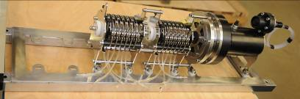 | 1.008,00

Battery cylinder and charger for peristaltic pump
Order no. | Qty. | Product |  | Prices - Euro
100.217 | 1 | Battery cylinder  - 24 Volt DC/10 Amp/h.  - Housing: AISI 316 stainless steel  - Operating depth: Max. 6000 m  - With room for mounting of time lapsed trigger system. (60.010)  - Length: 485 mm incl. Subconn connectors  - Diameter: 123 mm  - Weight: 27 kg incl. battery  - Exclusive cables and battery charger (100.235) | 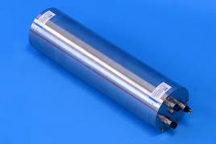 | 4.877,00

100.235 | 1 |  | Battery charger  - For Li-ion batteries  - Input: 110-240 VAC  - Output: 21,6 or 25,2 VDC  - Subconn connector MCIL4M |  | 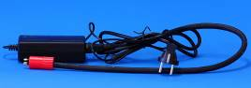 | 323,00
100.230 | 1 |  | Cable from battery cylinder to motor.  - Inclusive Subconn connectors, MCIL5M and MCIL5F  - Length of cable: 1,2 m |  | 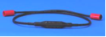 | 590,00
Time lapsed trigger
General:
Programmable timer for a maximum of 99 sessions.

Delay:
The delay between each sample is fully programmable at any value between
1 minute and 1080 hours (45 days).

Programming:
Software for Windows 98/2000/XP is included.

Interface:
USB or RS-485. Please specify upon ordering.

60.010-USB | 1 |  | Time lapsed trigger for multiple water sampler.  - USB interface  - Exclusive housing, cables and connectors.  - Delay: Fully programmable at any value between 60 seconds and 1080 hours. (Valid for each sample)  - Inclusive software  - Requires battery cylinder 100.217 |  |  | 1.203,00
60.010  RS-485 | 1 |  | Time lapsed trigger for multiple water sampler.  - RS-485 interface  - Exclusive housing, cables and connectors.  - Delay: Fully programmable at any value between 60 seconds and 1080 hours. (Valid for each sample)  - Inclusive software  - Requires battery cylinder 100.217 |  |  | 1.203,00
100.234 | 1 |  | Plug  - For switching on the timer when programming has finished.  - Subconn connector MCIL4M |  | 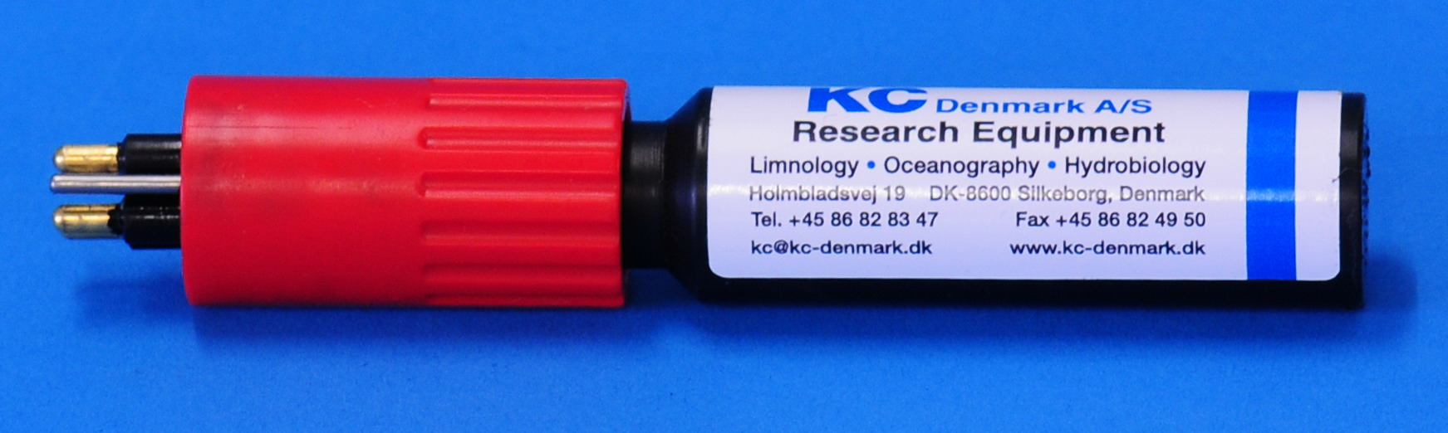 | 256,00
100.236 | 1 |  | Cable  - For programming the time lapsed trigger  - USB and Subconn MCIL4F  - Length: 2 m |  | 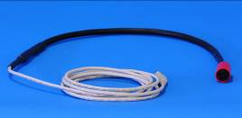 | 414,00
Technical information
Mechanical
Compensation: |  | Pressure compensated for 6000 m
Tubing: |  | Ø1,5 – Ø3,0 mm, 4 or 5 mm upon request.
Electrical:
Power supply: |  | Max. 24 VDC, recommended 10 – 24 VDC
Motor: |  | DC mini motor, 24 VDC (Swiss made)
Speed: |  | Max. 10 RPM (10 – 24 VDC). Speed is fully adjustable  by adjusting the voltage
Connector: |  | Subconn MCBH5M
Photo gallery
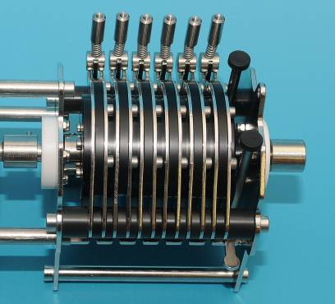 |  |  |  | - Closed position
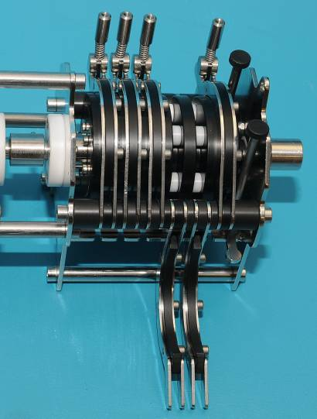 |  |  |  | - Each channel can be opened individually

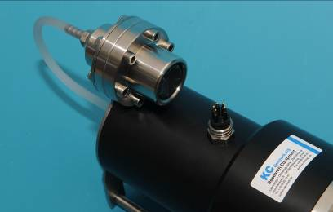 | - The pressure compensation  - Subconn connector MCBH5M
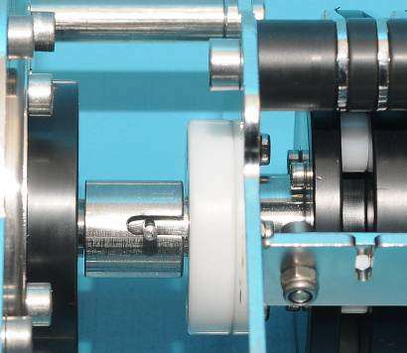 | - Connection between motor and the first module
- Bottom frame with support for 6, 12 or 18 channels
- AISI 316 stainless steel
- Shown with a 12 channel pump
- Dimensions: L x W x H: 930 x 220 x 26 mm

Shipment instructions
The following instructions are only intended as a quick guide for you if you wish to estimate the shipping costs.

Price does not include package, freight, insurance and delivery costs. Upon ordering, we will be pleased to quote CIP delivery to your place.
Pallet, L x B x H,
All prices are ex. VAT and valid until  December 31, 2017 | Rev.: March 30, 2017 - lkj
Subject to change in prices, specifications, dimensions and weights for all products. Any change can be made without previous warning.
Subject to any mistake, mistyping, misprints or any error occurred in all written material, caused by any software/hardware, virus, transmitting files via internet/copying of files or errors on any type of media.

KC Denmark A/S
Research Equipment
Limnology  Oceanography  Hydrobiology

E-mail: kc@kc-denmark.dk website: http://www.kc-denmark.dk/
Holmbladsvej 17-19, DK 8600 Silkeborg, Denmark. Tel. +45 86 82 83 47.
Bank: Sydbank. SWIFT: SYBKDK22 IBAN DK5070460000104832
VAT no. DK 29 61 96 62

